General Chemistry 2 | 3rd Quarter
Virtual Laboratory: The Study of Phase Change
January 14 2021
Virtual Lab Link

Substance | Constant : Varying
Substance | Temperature : Mass | Mass : Temperature
Napthalene | 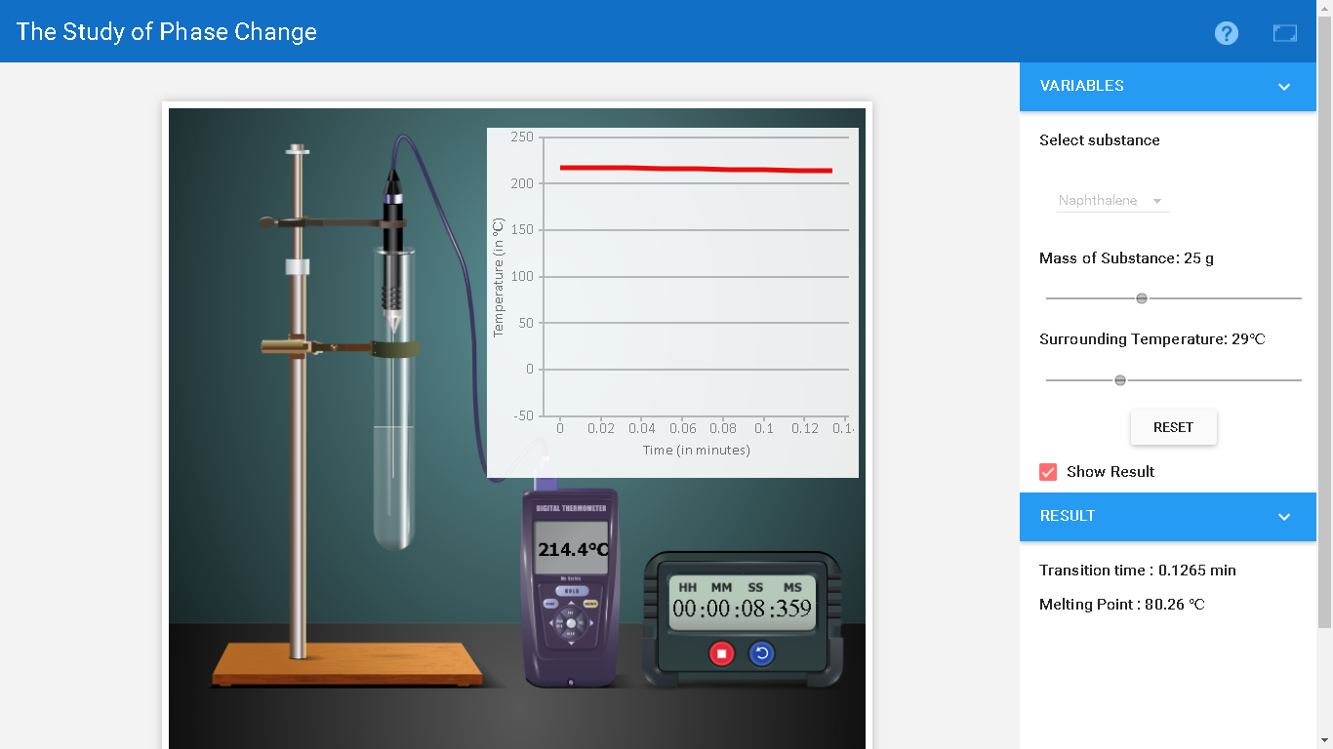 | 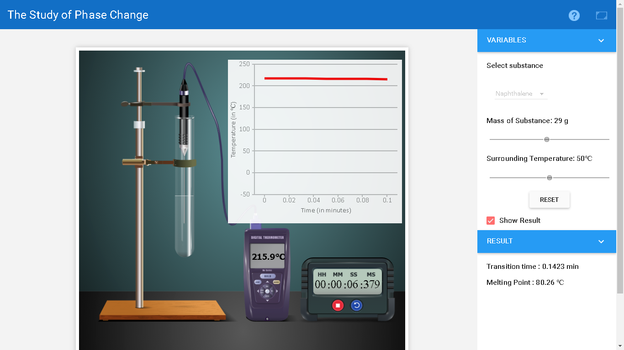
Napthalene | 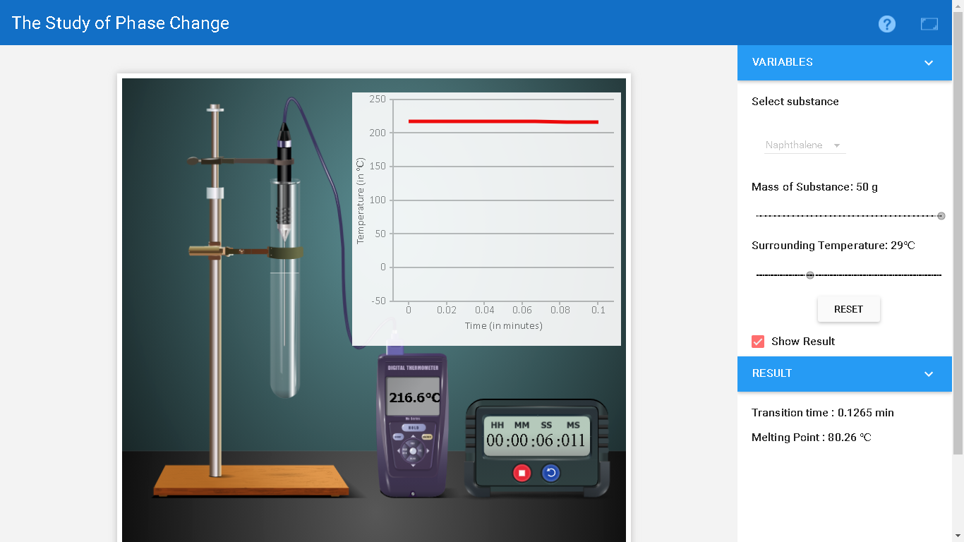 | 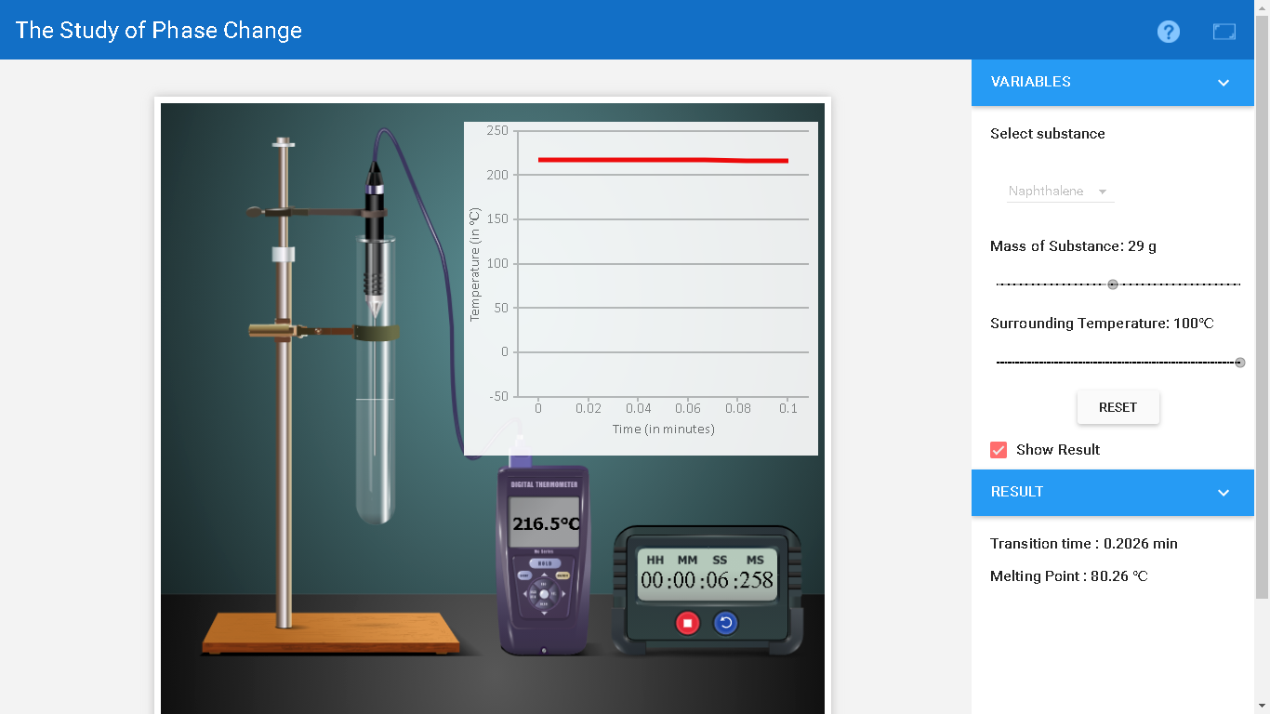
Ice | 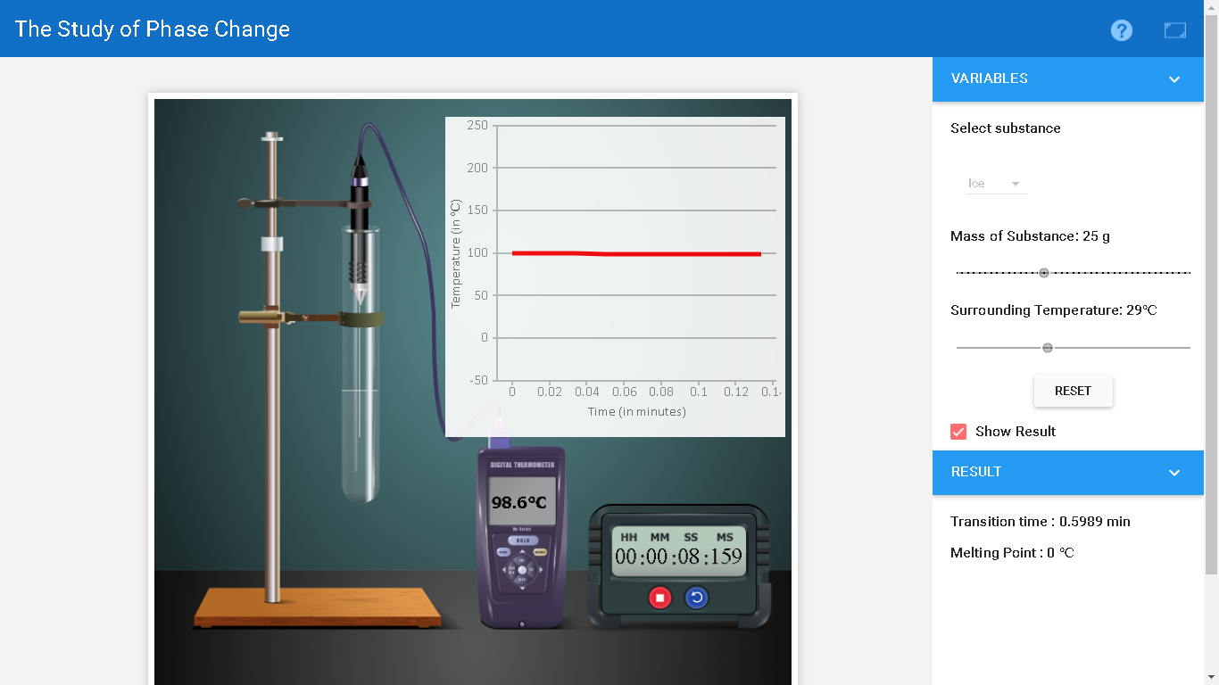
Ice | 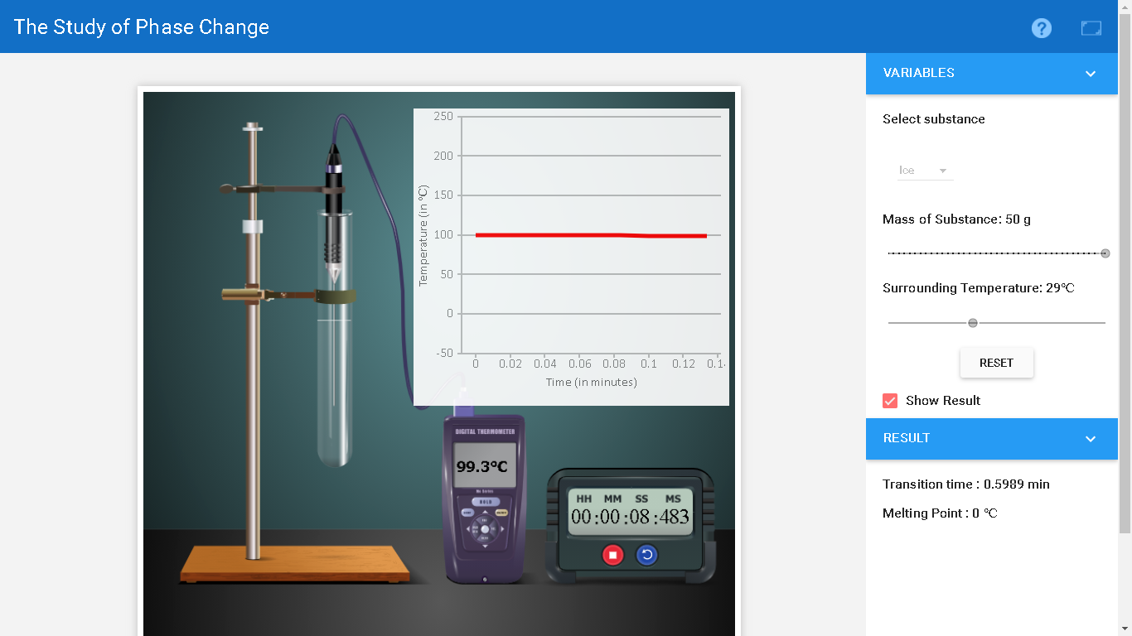

I didn’t continue to screenshot the other parts of the activity, because it kept on crashing my PC. :(

